After Action Review (AAR)
The following document will help you to reflect on your personal experience.

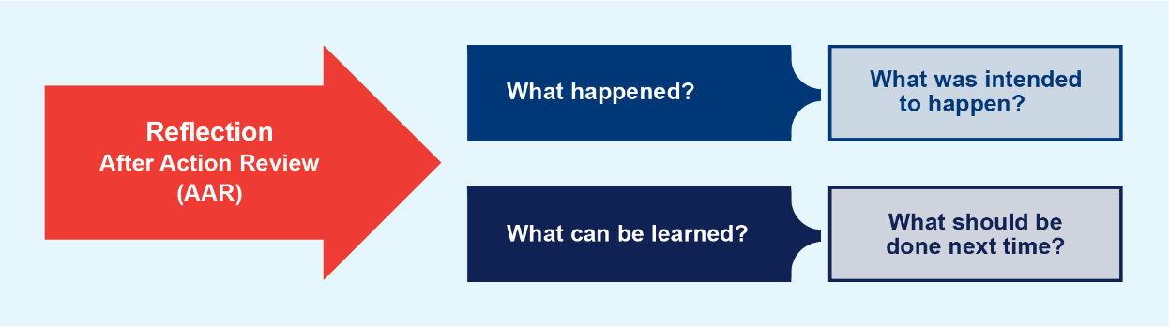
What happened? | What was intended to happen?
What can be learned? | What should be done next time?

